Messiah Student Ministries
Camper & Parent letter

Hey Campers,
We are so excited about camp and it’s just around the corner. Here are just a few reminders. Please bring your bags and sleeping stuff to church on Saturday 7/3 or Saturday 8/7 from 10am -11am, depending on which camp you are going to, so we can pack the trailer. Then you won’t have as much to bring on Sunday morning; also if you forget something this will give you a second chance to get it. We will be marking your bags with Blue tape and will be labeling and loading them by the camp you are in. (Energy or The Edge)

DO NOT pack your medications. Put them in a separate bag and give to Brian or give to leaders at Centerlake. (Please be kind to our nurses and only bring what meds you absolutely need for the week in original packaging, (OTC meds are not needed just put info on health form.)
We are meeting at the Church Sunday morning 7/3 or 8/7 at 8:00AM. Eat breakfast before you come!!

You will need money for lunch on the way to camp and dinner on the way home. You will want some cash for the camp store for the week and that will be kept in your canteen account for you until we leave to come home. I would suggest a total of $20 -$50 for the trip. We will shoot to be back around 7pm on Friday. We’ll call when we are about ½ hour away from church.
I have enclosed a packing list and some reminders just in case you didn’t get it or have misplaced it in the last few weeks. If you are sending up any electronics please bring a Qt. or Gal. bag with campers name on it on Sunday. We will have them put their stuff in it while at camp, so we can easily return it to them for the ride home.

Remember we strongly believe in giving students these opportunities and truly believe these camps are LIFE CHANGING. If the cost is a concern, please talk to us. Our church family believes that camps and retreats are so important for our students’ development, and they have provided thousands of dollars in scholarships over the years! Also while it may be difficult for you to go a few days without talking to your child. This is an important part in allowing them to start to mature. We will do our best to post a few photos on Facebook, and if you really need we can send you a few photos of your child via text message throughout the week. Pastor Kurt’s cell number is (815) 557-5392. Direct phone calls to camp are for emergency’s only. But please send letters, emails and or packages the kids love them.

Finally, MSM consent form (enclosed),( http://mlcjoliet.org) is needed at Messiah ASAP. CLBC camper health forms and copies of your insurance card are due to CLBC, ASAP. You can print the CLBC health forms online at www.Centerlake.org. If you have any questions don’t hesitate to call the office (815) 741-4488.
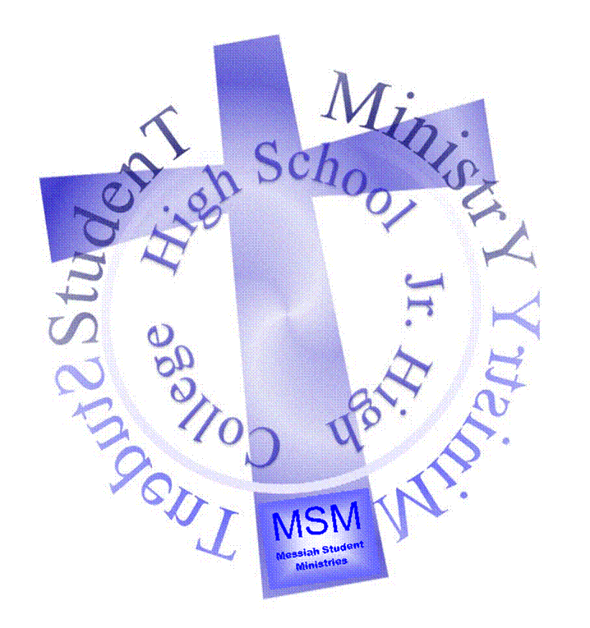

Brian Phipps
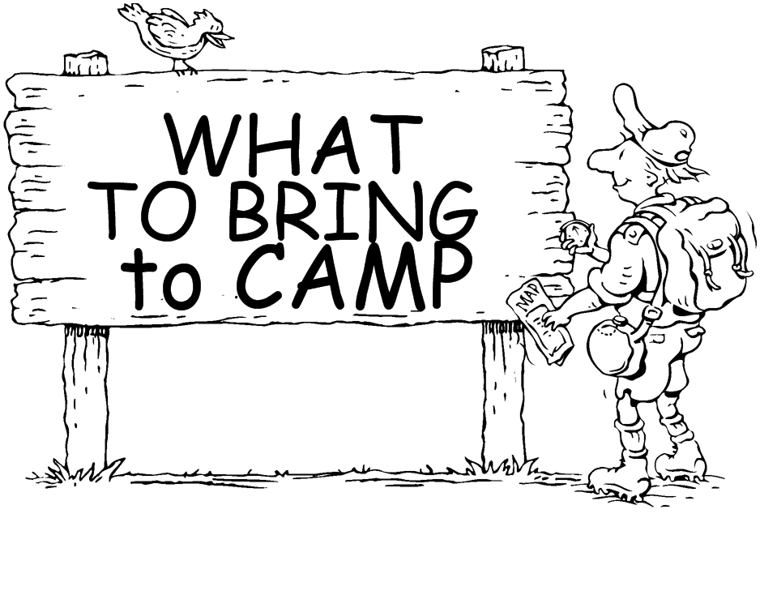

Sleeping bag or Twin bedding
Beach Towel
Wash cloth and towel
Toiletries
Bible
Clothing for 5 days
Modest swimsuit
(ladies, no bare midriff)
Extra clothing, you never know!!
Jacket or hoodie, at least 2 pair long pants
(Be prepared for all temperatures, mornings and evenings can be cool)
Flashlight, Pillow
Modest PJ’s,
Spending Money, Money for meals on the road
Money for Activities: Horseback riding or Paintball
Books & Game systems are ok for the drive, but
they will be locked up in the bus or van when we get to camp.
Please no headphones for electronics.
(We want you to interact with each other)
Insect repellant & Sunscreen
Meds to be given to Brian or camp leader, do not pack in suitcase!

