Messiah Student Ministries
Summer Camp letter

Hey Campers and Parents,
We are so excited about camp and it will be here before you know it. If you are getting this letter your student is in the grade level we are taking, here are the details!
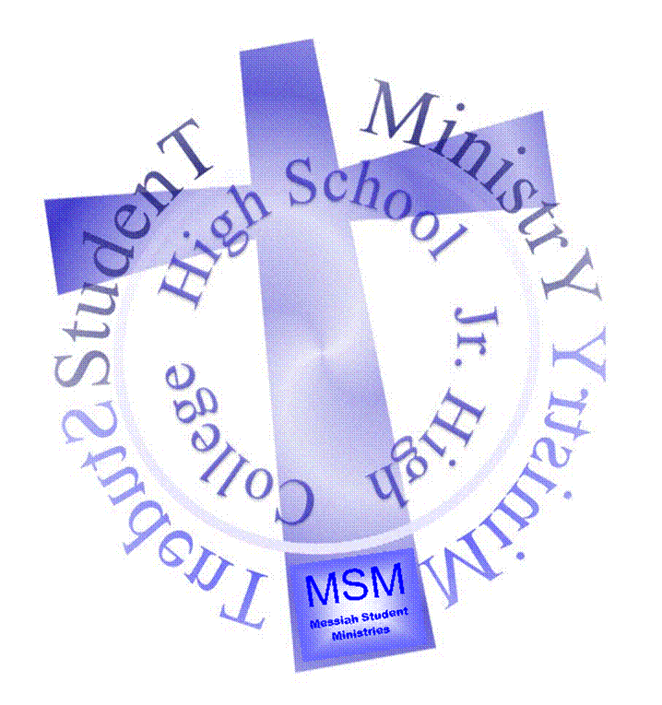
Dates: June 26th-July 1st. The cost is only $350 for Energy camp (5th-6th) and $360 for Edge camp (6th-9th) you save by doing the online registration at www.centerlake.org. and using the discount code (Church Discount).

Camp is for all students entering the 5th grade through 9th Grade this fall 2022. There are 2 camps that we are taking students to; Energy for the 5th-6th grades and The Edge for 6th-9th grades. If you have a student entering 6th grade this fall you can choose which camp they feel most comfortable with. The Jr. Highers have a few more things available to them like the high ropes course! Brian will be up there all week with the campers. The staff goes through over 30hrs of training each spring. Pastor Dave has worked with this camp for over 20 years he stands by them! It is the same location we have gone to for winter camp in Tustin MI. The drive is about 5hrs for summer camp.

If you as a parent are not sure if you or your student is ready for this please talk to Pastor Kurt, PD2, or Youth Director Brian. We strongly believe in giving students these opportunities and truly believe these camps are LIFE CHANGING. If the cost is a concern, again please talk to us. Our church family believes that camps and retreats are so important for our students’ development, and they have provided thousands of dollars in scholarships over the years!

You will need money for lunch on the way to camp and for dinner on the way home. You will want some cash for the camp store for the week and that will be kept in your canteen account for you until we leave to come home. I would suggest a total of $20 -$50 for the trip. We will shoot to be back around 7pm on Friday, and we’ll call when we are about ½ hour away from church.

We will be Packing the trailer on Friday 6/24/2022 from 10am-11am, then meeting at the Church Sunday morning 8/8 at 8:00AM to head to camp.
Eat breakfast before you come!!
I have included a sample packing list on the back of this letter.
Finally camper health forms and copies of your insurance card are due ASAP. You can print the health forms online at www.Centerlake.org. If you have any questions don’t hesitate to call the camp office (231) 829-3441 or the church (815) 741-4488

Brian Phipps

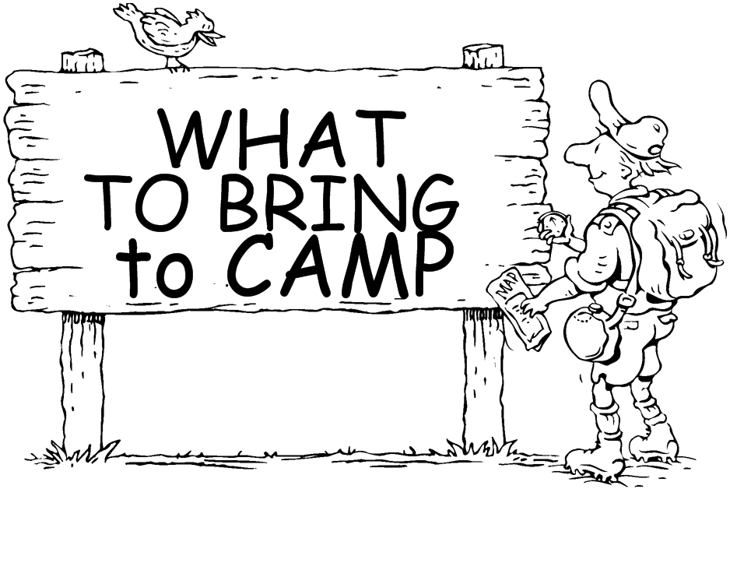

Mulitple masks
Sleeping bag or Twin bedding
Beach Towel
Wash cloth and towel
Toiletries
Bible
Clothing for 5 days
Modest swim suit
(ladies, no bare midriff)
Extra clothing, you never know!!
Jacket or hoodie, at least 2 pair long pants
(Be prepared for all temperatures, mornings and evenings can be cool)
Flashlight, Pillow
Modest PJ’s,
Spending Money, Money for meals on the road
Money for Activity’s: Horseback riding or Paintball
Books & Game systems are ok for the drive, but
they will be locked up in the bus when we get to camp.
Please no MP3 players or headphones for the games.
(We want you to interact with each other)
Insect repellent & Sunscreen
Meds to be given to Youth Director Brian, do not pack in suitcase!

Special notice:
New Parent & Camper (all are welcome)
information meeting for summer camp
March 20th, 2022 right after the 11am service
Location: Youth Room
